Temasek Polytechnic
School of Informatics and IT

Diploma in Information Technology (IT)
AY2013/2014 Apr Semester Level 3

Software Requirement Specifications (SRS)

Project Particulars

Tutor | Ms Serena Tai
Class | P02
Project Title | Delonix Regia Hotel Management System

Project Team’s Particulars

Matric Number | Student Name
1101387G | Chua Edwin
1101137F | Marvin Koh
1105342H | Leonard Choo

Revision History

Date | Version | Description | Author
22/05/13 | 0.1 | First Integration | Marvin
22/05/13 | 0.2 | Revised SRS | Edwin
22/05/13 | 0.3 | Revised SRS | Edwin

Table of Contents

1. DISTRIBUTION OF WORKLOAD 4
2. OVERVIEW OF REQUIREMENTS 4
1.1 System Functions 4
1.2 User Characteristics 4
1.3 General Constraints 4
1.4 Functional Requirements 4
1.5 Data Requirements 4
1.6 User Interface Requirements 5
1.7 Interface with Other Systems 5
1.8 Assumptions 5
2 OPERATIONAL AND QUALITY REQUIREMENTS 5
2.1 Operating Environment 5
2.2 Development Constraints 5
2.3 Performance 5
2.4 Availability 5
2.5 Security and Access Control Requirements 6
3 SPECIAL REQUIREMENTS 6
4 REFERENCES 6

DISTRIBUTION OF WORKLOAD

Requirement Gathering | Members
1 | All
1.1 – 1.5 | Chua Edwin
1.6 -1.8, 3 | Leonard
2.1 – 2.5 | Marvin

OVERVIEW OF REQUIREMENTS

System Functions
Delonix Regia Hotel Management System is a function that will allow Delonix Regia to manage their customers and interal operations more smoothly.
Staff will be able to login to their respective accounts to access the different functions.
The staff will be able to access the end user management system, and reports system.
The housekeeping system will keep the records of the staff as well as their personal details, the end user management system will allow the end users to access the room availability and booking functions as well as certain parts of the report system.

The reports system will produce 5 types of reports:
- Room Status report
- A list of all guest in one room
- A list of all guest in all rooms
- Room Occupancy report (Statistics for room occupancy on a daily/weekly/monthly/yearly basics)
- Housekeeping report

The system will also allow reports to be previewd before being printed.

User Characteristics
End users (Receptionist):
The end users are the front of the hotel, where they will assist the customers as well as the management. They will be able to fully access the room availability and booking system to create and update the data. They are also able to access certain parts of the report system and print reports

Management (Managers, etc):
The management are the ones who manages the staff as well as the report system. They wil be able to fully access the room availability and booking system, the reports system as well as the housekeeping system. The management will also be able to view, create, update and delete staff details. They are also the ones who will generate the reports.

Admin (Mr & Mrs Wang):
The admin are the owners of the hotel and the hotel management system. They will be able to fully access all systems.

General Constraints
The general constraints of the project is that the project deadline of 24 June 2013 as well as a budget of $70000, working on a computer specifications of OS Window 7, 1GB memory, 100GB hard-disk space, as well as working on a 2 tier architecture.

Functional Requirements

Log in and Log out System:
The system will allow staff to log in after they have entered their username and password, the system will then redirect them to the main page of the hotel management system.

The system will log out the staff when the staff clicks the log out button, which will redirect the staff back to the home page

Room availabliltiy and booking system:
The system will redirect the staff to the room availability and booking system when the staff clicks on the RABS link.
The system wil display several buttons:
- Make Bookings
- Update Bookings
- Cancel Bookings
- Check room availability and status
- Update room availability and status

The System will display a list of information need to make a booking when the staff click on the make bookings link, the system will save these details to the database after the staff has clicked the create booking. The system will then display the newly created booking details.

The system will display a textbox for the required booking ID, the system will display the booking details that matches the booking ID in edited textboxes. The system will save the updated information into the database when the staff has clicked the ‘update booking’ button. The system will then show the updated information.

The system will display a textbox for the required booking ID, the system will display the booking details that matches the booking ID. The system will display a confirmation message when the staff clicks on the delete booking button, the system will delete the booking from the database when the staff has confirmed the deletion of the booking.

The system will display a dropdown menu that will allow the staff to check the availability of the rooms by levels or by status.
The system will display a table arranged by level and room number if the levels option is selected, it will display by status(Vacant, etc) if the status option is selected.

The system will display a dropdown menu that will allow the staff to update the availability of the rooms by room number.
The system will display the room’s details and will update the status of the room when the staff clicks the ‘update room’ button

Housekeeping System:
The system will direct the staff to the housekeeping section when the staff clicks on the housekeeping link.

The system will display 4 buttons of ‘Create Staff’, ‘Update Staff’, ‘Delete Staff’ and ‘Search Staff by..’ .

The system will display a form to create a staff when the ‘create staff’ button is clicked, the system will then save and create a staff when the ‘create staff’ button is subsequently pressed.

The System will display a textbox when the update staff button is clicked, the system will retreive the staff information of the entered staff ID, when the go button is clicked. The system will then display the staff information in editable textboxes, after which the system will save the staff details to the database after the ‘update’ button is clicked.

The System will display a textbox when the ‘delete staff’ button is clicked, the system will retreive the staff information of the entered staff ID. The system will display a confirmation to delete the staff when the ‘delete staff’ button is clicked. The system will delete the staff from the database after a confirmation is given.

The system will display a drop down list to allow the searching staff by staff ID, name or duty type. The system will display the particular staff if the search is by staff ID, the system will display staff details with the name or duty type if they are selected.

Invoice Generation:
The system will prompt for the booking ID when the staff enters the generate invoice system. The system will display the invoice details and display the total amount.

Reports System:
The System will redirect the management staff to the reports page, the system will display 5 buttons for each of the 5 reports, namely:
- Room Status
- All guest in a room
- All guest in all rooms
- Room Occupancy
- Housekeeping
The system will prompt the staff for the type of report (daily, weekly, monthly, yearly) and will display the report based on the report chosen and the report type.

The System will display a preview of the reports to be printed when the staff clicks on the ‘preview before printing’ button.

Data Requirements

Guest details – This will allow the system to search guest by their details:
- Nric
- Last Name,
- First Name
- Number of Guest
- Email address
- Additional guest details – size of bed, smoking/non smoking room, late check out.

Booking Details – booking details of the guest
- Booking ID
- Nric

Check in details – check in details of the customers
- Check in date
- Check out date
- Check in time
- Check out time

Contact details – Contact details of customers and staff
- Street
- Block
- House number
- Postal code
- Country

Staff details – This will allow the system to search the staff by their details
- Name
- Date of birth
- Bank account number
- Phone number
- Duty type

Invoice – details of the Invoice
- Number of nights stayed
- Room rates
- Mini Bar used
- Check in date
- Check out date
- Additional cost
- Payment method

Staff Account – Staff account details
- Staff ID
- Password

Room Details – Room Information
- Room Status
- Number of Guest
- Room number
- Room location
- Room type

User Interface Requirements

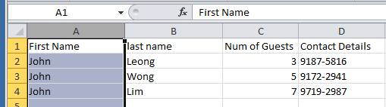
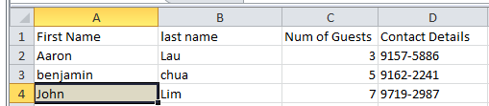

For those bars with multiple customer of the same name the bar is high-lighted in gray double clicking on it john a list of. The customers sharing the name John are listed out this way
Allowing for better customer management especially when handling multiple customers with the same name
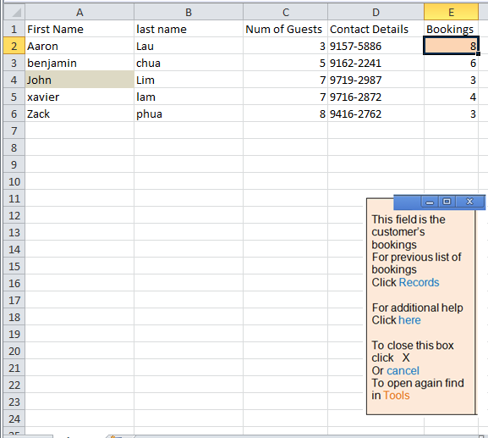
When a particular box is clicked a list of options will be presented to the user

A list of suggestions with help and documentation provided to the user
(Click here for additional help)

User control and freedom allows users to cancel the info box

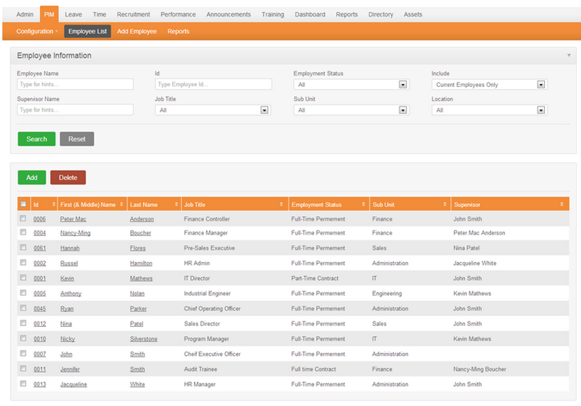


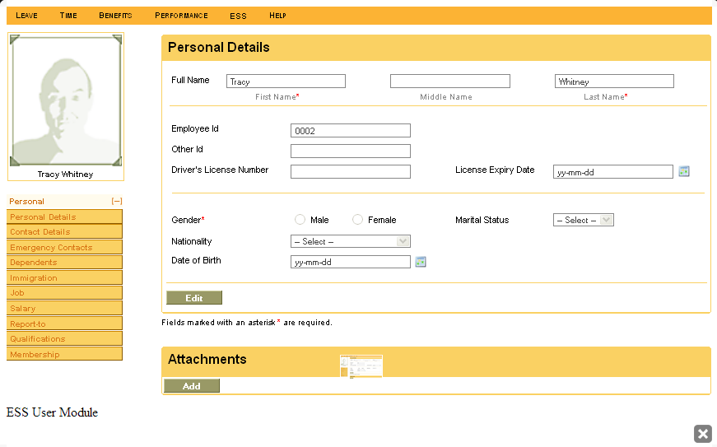

This feature will keep the record of the staff, certain field must be filled and the employee ID is unique
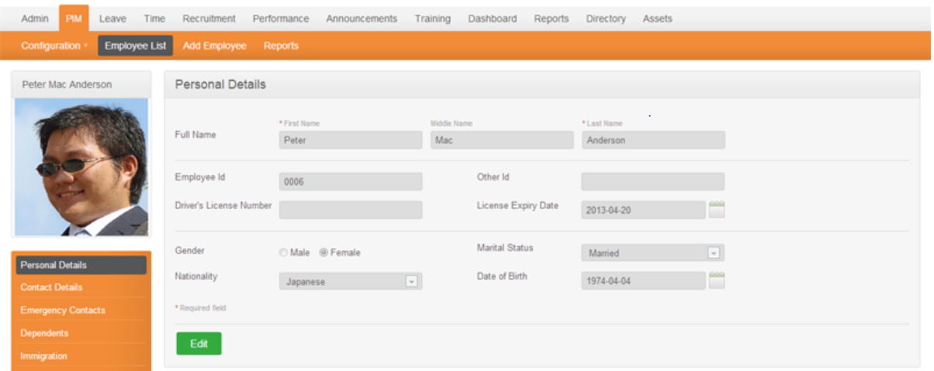

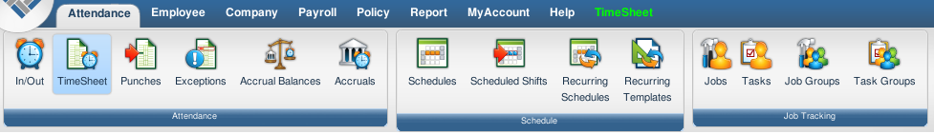
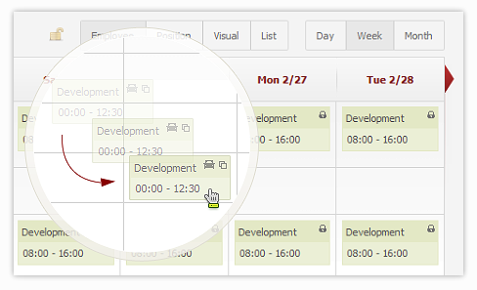
This is a feature where management staff can assign a task to the employee
Create a work schedule for the staff, and simply by shifting a task box to another
Employee’s column
The scheduler will reassign Employee if there was a problem scheduling
Also if the employee has successfully applied for leave it would prevent
A shifting of the task to that certain day or work-hours
A function to print the schedule is also available so they can print a copy
To pass to the employee for reference
This is a good feature for the house keeping report

Also a feature is the house keeping overview to view multiple employee work
Schedule at once which helps to prevent clash of time schedule

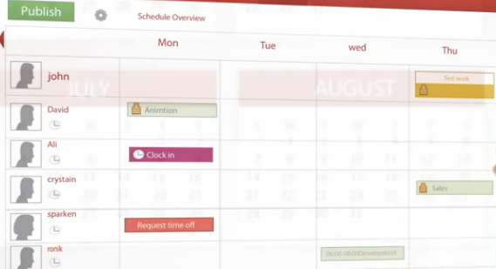

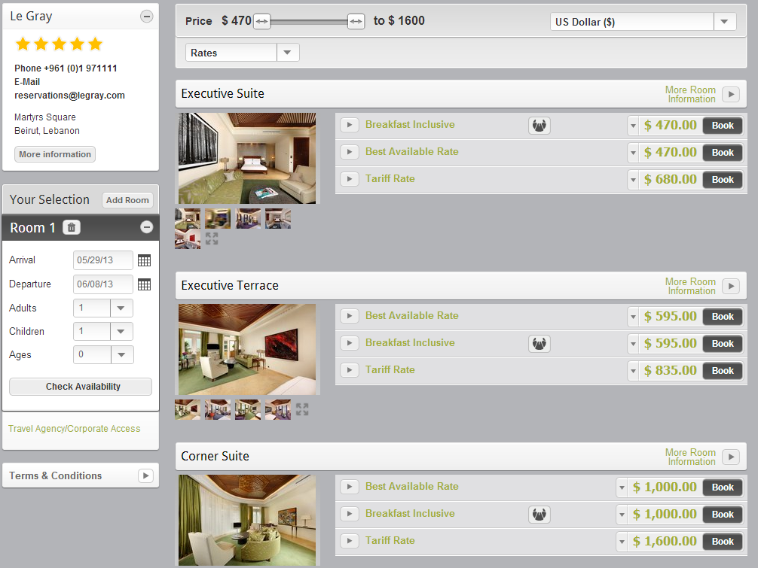
Room Booking

For the hotel booking of a room accesible to all users click book to place a booking on the room
Inclusive or exclusive of providence of breakfast has already been calculated for convenience

The reporting
A drop-down box which only allows
Three choices
This is relevant with IHCI error prevention

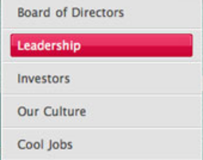

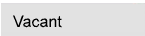

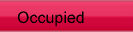
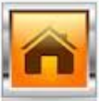

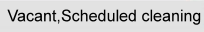



All guest in a room


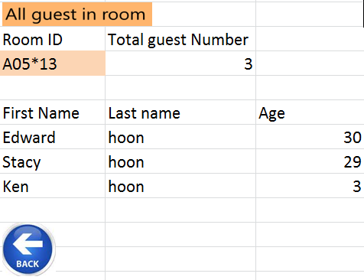

The function all guest in room is darker in colour because it is the current page, slightly skin coloured Room ID is clickable to view the room details
The print function will allow a report to be printed out

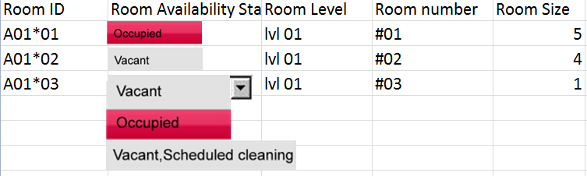

Screenshot of all the Guests in a room, all the rooms are listed for viewing clicking on the room ID will link users to the page details of that chosen room

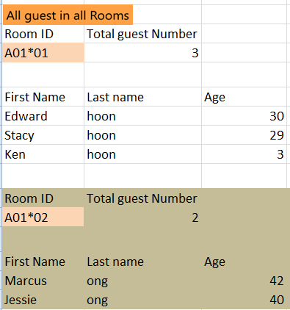

Room Occupancy Report

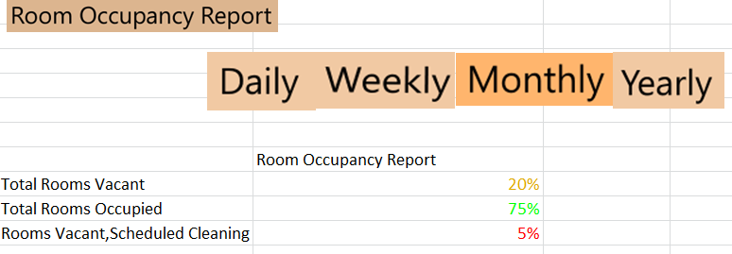

The Room Occupancy report can only be accessed by the Admin. The colour coded number helps in learning more about the current room status

If you are satisfied with the print preview please click on
Again.

HouseKeeping report
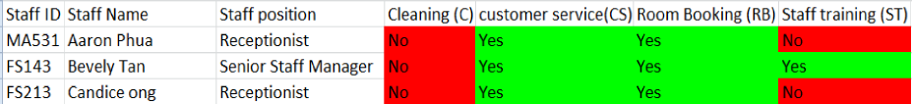
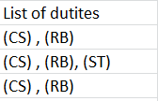



If you are satisfied with the print preview please click on

Interface with Other Systems
There is currently no interfacing necessary

Assumptions
An assumption implied was that the system could possibly be made accessible from the users own digital equipment laptop or internet capable mobile phone,

OPERATIONAL AND QUALITY REQUIREMENTS

Operating Environment

Processor: Intel Core i5
Processor can be changed to improve processor performance, and increase ability to multitask.

Memory: 1GB
Memory can be increased to make way for greater traffic in the future; to raise productivity and efficiency, specifically in Room Availability Checking and Housekeeping Management.

Hard Disk: 100GB
Expandable to accommodate for more data entries; Hard disk drive can be expanded internally or externally. However, note that if Hard disk is expanded externally, there will be mobility, thus allowing interchanging between several external hard disk drives, making storage virtually infinitely expandable. The current technology is SATA hard disk drives Storage of booking details and housekeeping management details will be stored separately.

This suggests more bookings will be made within the defined 5 years duration.


Operating System: Windows 7
Operating system can be re-installed to be made compatible with programs running on it. (We would recommend a Windows OS over a Mac OS as Windows are compatible on most computers. Another alternative would be Linux Ubuntu as it has a built-in driver set which means time is saved on downloading and installing drivers for everything.)

Internet: Broadband connection
It is dependent on the local connection speed within the hotel.

*All components listed above are eligible for upgrade. All components can be upgraded individually. It is running on a standalone workstation. This single computer is located at the reception staff area.

Development Constraints
During the coding phase, the software required to carry out the process is only available on the virtual environment within the workstation as well as within the compounds of the database server.

Because system has to on 24/7, not a lot of opportunities for bug fixes, improvement and maintenance.

Performance
Maximum time allowed for system to respond to command given by user:
2 milliseconds flat on both Peak and Non-peak hours
Peak hour: 11:00am – 12:00pm (check out time)
*Low hours: 12:00am – 6:00am (midnight to sunrise)

Maximum time allowed for system to cold boot: 20 seconds
Maximum time allowed for system to warm boot: 5 seconds

Availability
System shouldn't go down at all; it has to be on 24/7.

However, to counter incidents such as overheating and hard disk drive failure from occurring, additional hard drive coolers will activate during peak hours and will extend 2 hours after the peak hours to ensure the temperature of the hard disk drive is within the safety range.

On top of that, the hard disk drive will engage low energy mode during *low hours in order to conserve energy and not overheat/over utilize the hard disk drive.

Server maintenance is to be held monthly.
From 2:00am to 3:00am on the first Sunday of every month.

Security and Access Control Requirements
As it is a standalone machine located at the reception staff area, all levels of users are able to access the machine. The primary security measure is to have the ADMINISTRATOR to log in and connect the hotel system to the database and only the ADMINISTRATOR can disconnect the system from the database, should there be a case of rollback or migration.

The secondary measure would be applicable to the machine itself. During boot up, only the MANAGEMENT level and ADMINISTRATOR can log in to use the PC. The reception staff can only use the hotel system after a staff from the MANAGEMENT level has logged in.

3 levels of Access Control

 | End User (Reception staff) | Management | Admin
Room Availability/ Booking |   (full access) | (full access) | (full access)
Report Generating | (selected) | (full access) | (full access)
Housekeeping and Staff management |  | (full access) | (full access)
User account and login creation  Allows admin to create new accounts for new staff/user |  |  | (full access)

Report Generating

 | End User (Reception staff) | Management | Admin
Room Status
List all the rooms in the hotel in 3 status:
- Available/Vacant
- Occupied
- Vacant & scheduled for cleaning
Occupants
in 1 room at any instance only
(e.g. 2 adults & 3 children in room 1765)
Occupants
in all room at any given point of time (e.g. On a particular date 1st Jan 2013)
Room Occupancy Report
Statistics of room occupancy by
- Daily,
- Weekly,
- Monthly,
- Yearly.
Housekeeping Report
List duties staff has been allocated to. Generate housekeeping schedule by
- Daily,
- Weekly,
- Monthly.

*Additional feature: users may preview reports before printing.

SPECIAL REQUIREMENTS

Record longer than 5 years are dumped
While creating the option to archive records older than 2 years
Which helps to reduce memory usage

REFERENCES

[List any books or web site that you have used when preparing this requirement specification.]
http://www.orangehrm.com/
http://www.shiftplanning.com

